- Project Introduction
What are the 7 main things you are going to learn? | Green Screen,

- Acquiring Music
What program did he buy for his school? Paste Link to the right
How much is the FL Studio Signature Bundle?
Creative Commons  What do the following mean? | ANSWER
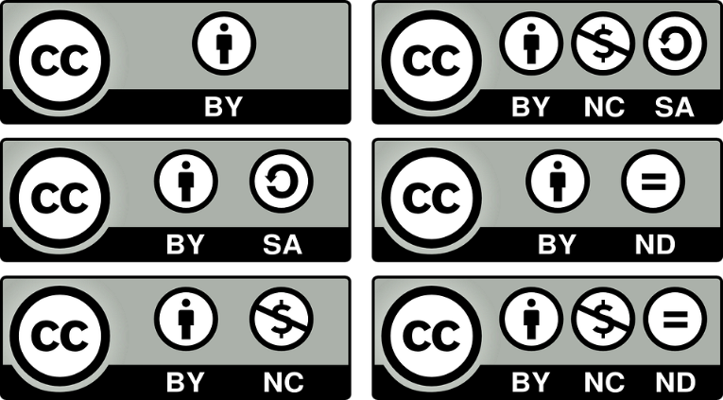
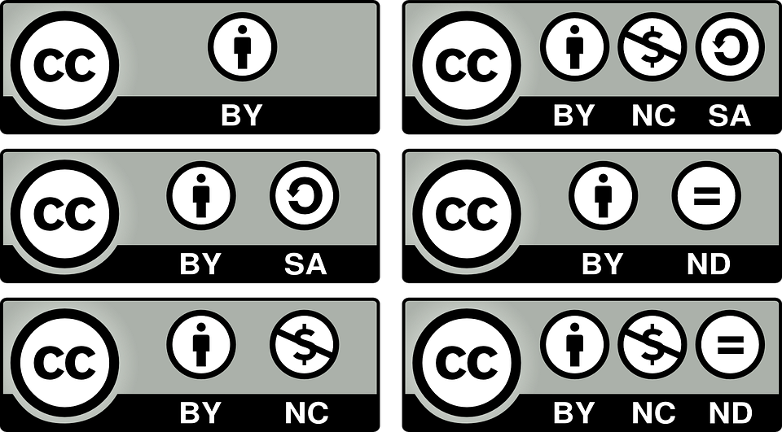
Take a screenshot of your PR folder on your OneDrive  (Delete mine first) | 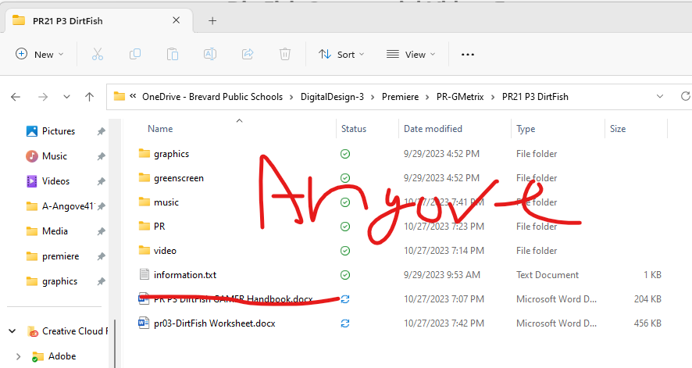

- Import and Relinking
Take a screenshot of where your premier project is located. (Delete mine first) | 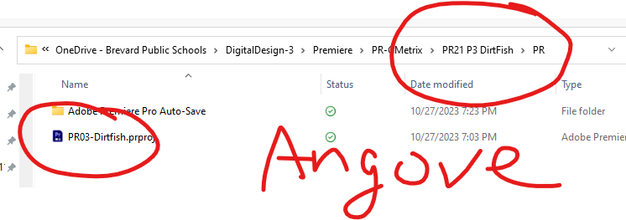
What happens when you change a name in your OneDrive folder of a video that you have already brought into Premiere?
How does one fix it? (THIS IS ON THE TEST!!!)

- Importing Photoshop Files
What is a bin? How do you make one?
In CarAnimate file, what are the 4 choices?
Which choice keeps the files separate?

- Clip Marker and Syncing Clips
Take a screenshot of the mark in/out points in your first video.  (Delete my picture) | 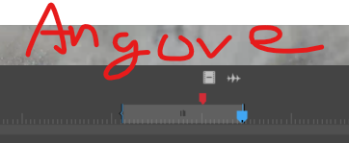
How does one use snap on the markers?

- Point Editing
Why do we rename sequences
Take a screenshot of your Project Panel folders.  There should be 5 folders IF you are following him.  Video, Audio, Greenscreen, graphics, Sequence  IF you are doing it like I do, media and sequence folder  (Delete my picture) | 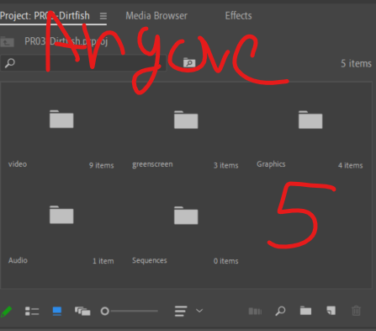
After importing ALL 9 videos, take a screen shot of your Project Bin. EACH video should have the blue icon that says you used it.  (Delete my picture) | 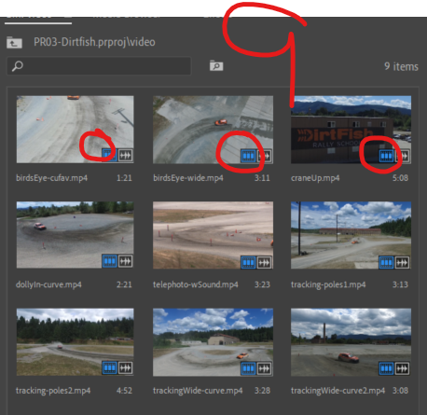
Briefly describe 3 point editing
Why would one use it?

- Labeling, Renaming
Briefly describe how to change a poster frame.

How does one rename a file on the timeline?
How does one change the color of a clip

- Intro to Green Screen
What is the guy’s daughter’s name>
What is the effect that one used to key out a green screen or Bluescreen?
What are the 3 output choices
How did he clean up the green screen?
Under matte generation, what did he choose?

- Managing Tracks
What tool maximizes or minimizes the timelines?
What are the 3 option under the timeline options to view video
Take a screen shot with just the head thumbnail.  (Delete my picture) | 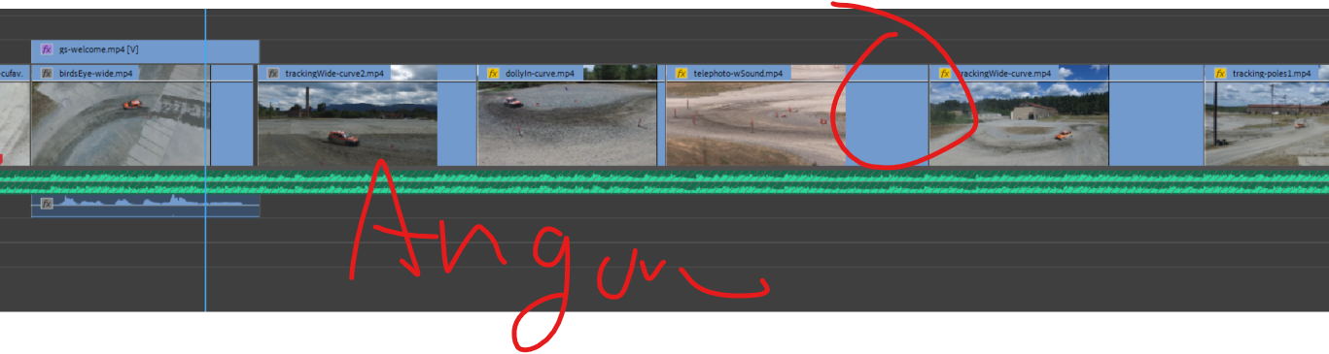
What is a “chunk” of video on your timeline called?
What is the whole video called on the timeline
How many video tracks can you have?
Go online and find a professional movie timeline with a bunch of tracks.  (Delete my picture) | 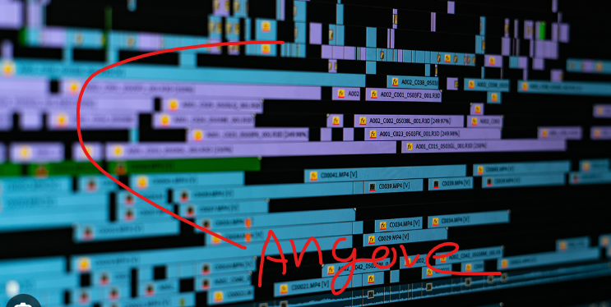
How can one easily make more tracks?
Why should one rename their tracks and paste a picture of your tracks.  (Delete my picture) | 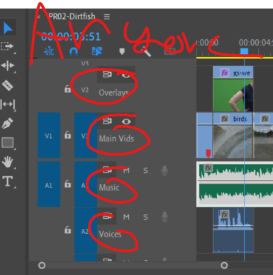
At 5:00 on the video – what is source patching?
What is the difference?
Toggle track targeting? VERY IMPORTANT!

- Animating an Effect
What keyframe did he use to animate the girl?
What effect did he use to blur the background?
When he right clicked on the percent blur keyframe, what did he change?

- Opacity Mask
What are the 3 options for the Opacity Mask
Take a screen shot of your Opacity Mask  (Delete my picture) | 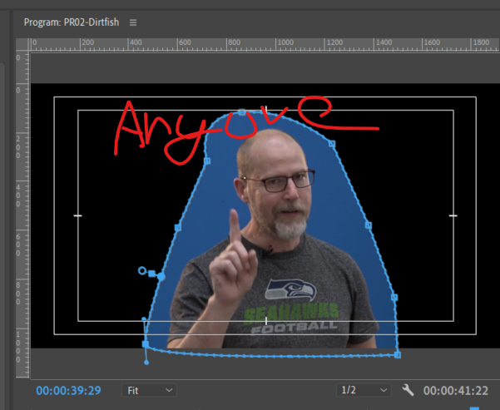

- Blend Models and Nesting
How does one change the opacity of a clip?
Which blend mode did you like the best?
What is it called when one combines two clips (Hint:Birds)

- Track Matte
What tool did he quickly use to slow down a clip?
What is it called when you can “see through” the text?
What layer did you apply the track matte to? Top or Bottom (2:30)
Change your metal background with Lumetri colors and put a picture in here – should be easily noticeable. (4:09)  DO NOT DO A SOLID COLOR | 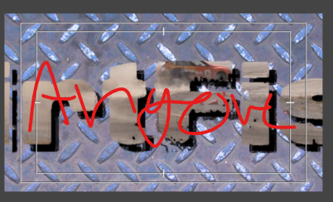
- Auto Ducking
How does one fix the low voice level and make the voice show up on both channels?
What audio setting did you choose for the voices?
What audio setting did you choose for the music
What drops the audio automatically?
When does the “magic” happen? (3:00)
What audio transition does he use?

- Credit Roll
Take a screen shot of the tracking key and describe what it does. 1:19
Take a screen shot of the leading key and describe what it does
Take a screen shot of the kerning key and describe what it does

- Nesting a Sequence
What are the handles the you can move to change the trajectory of the car? (Double Click to access)

- Exporting Multiple Sequences
Take a screen shot of the 4 sequences in the sequence folder.  You do NOT need to rename sequences but you wil export them all. | 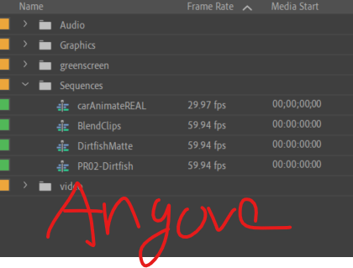
Go to 3:02 to export using media Encoder. | Nothing here

- Project Manager
What does the Project manager do?
You do NOT need to do this – just watch | Nothing here

